Lab Exercise 1
Introduction to Bluemix
(Version 2.0)

Author(s):

Mangalaganesh Balasubramanian, GBS BPM & I , Australia
Kaustubh Roy Chowdhury, GBS India
Shri Santhana, GBS Singapore
Manendra Rawat, GBS India
Shahir A. Daya, GBS Cloud CoC
William A Brown, GBS Cloud CoC
Table of Contents

1 Pre-requisites to participate in this lab 3
2 Learning objectives 3
3 Create a JEE based Web Application 3
3.1 Setup MongoDB Service for the Web Application in Bluemix 3
3.2 Create Bluemix Server in Eclipse 9
3.3 Create Dynamic Web Project using Eclipse 12
3.4 Publish Web Application to Bluemix 19
3.5 Test Web Application 23
References 25

Pre-requisites to participate in this lab
What do you need to participate in this lab? You need an IBM Bluemix account
(https://ng.bluemix.net), the Eclipse IDE, and a modern browser like Chrome, Firefox, IE10+ or Safari.

Learning objectives
This lab shows how to create applications that run on IBM Bluemix and makes use of Bluemix runtimes and services. The Java Liberty runtime is used with a MongoDB service. Bluemix supports multiple runtimes and frameworks, as a scallable polyglot application platform.
When the lab is completed, your application will be running on the web and will be able to be administered (stop, start, monitor) via the Bluemix user interface.

Create a JEE based Web Application

Setup MongoDB Service for the Web Application in Bluemix
In this section you will create a mobileapp using Bluemix.
- Login to Bluemix (https://ace.ng.bluemix.net) and navigate to your dashboard.
- Click on Manage Organizations which is visible when you click on the organization tree icon next to your ORG name.
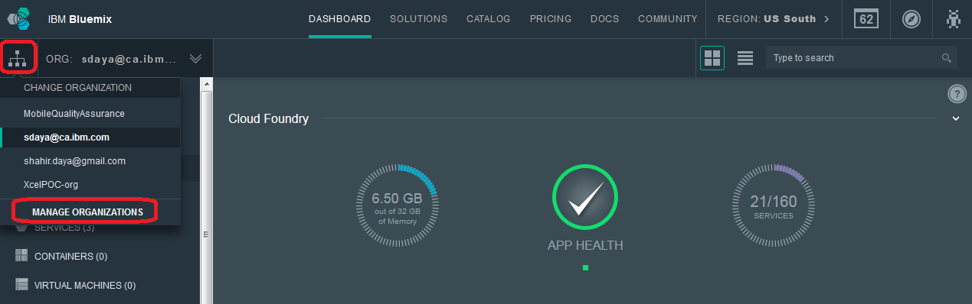
Note that most of you will likely only see one organization which will be your login email address. You will only see multiple organizations if you have been invited by that organization to work in their organization/space as is the case for the above screen illustration.
- Click on Create a Space
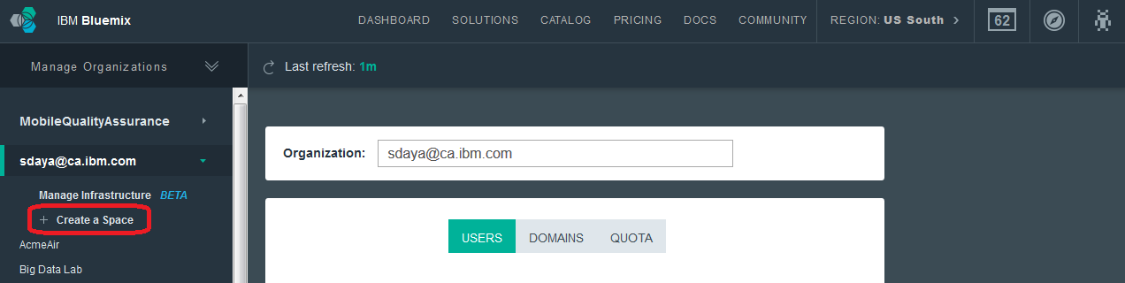
  - Specify a name for the space. We Chose "CloudBootcamp" as the name for our space
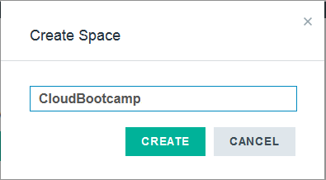
  - Click the CREATE button to complete the Space creation.
  - Ensure that you have complete access to this space. In other words you should have access to this space as MANAGER, DEVELOPER and AUDITOR.
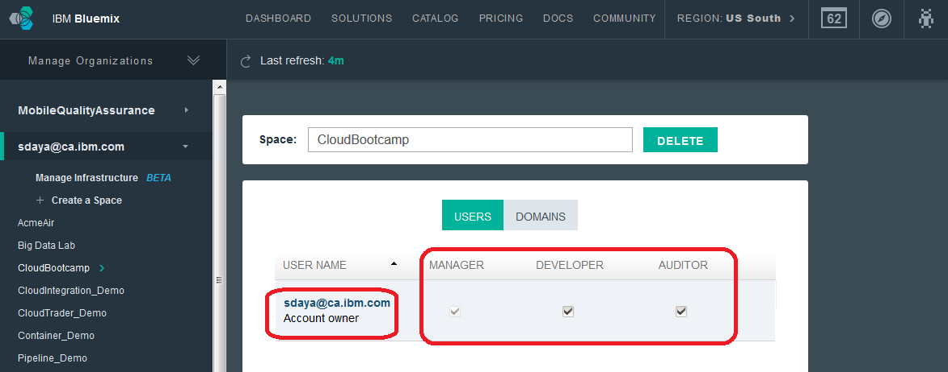
- Switch to the CloudBootcamp Space on your Dashboard.
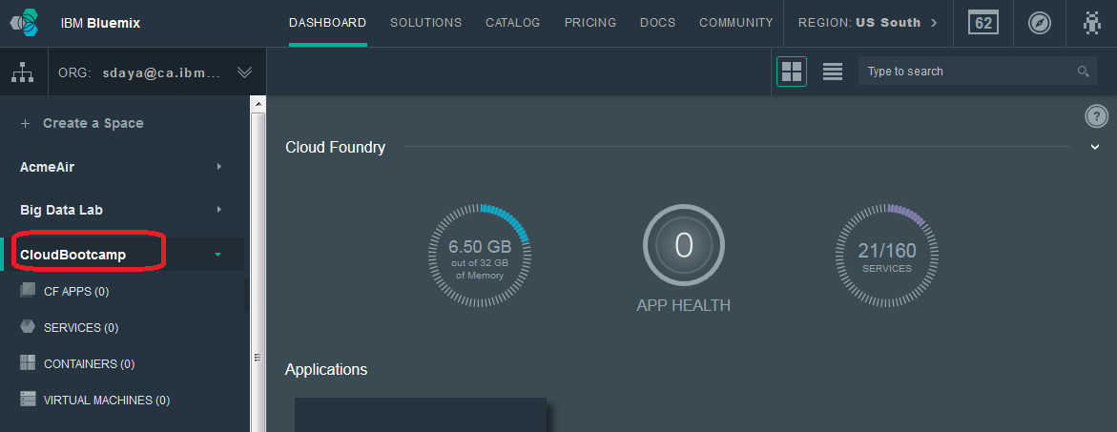
- Add a MongoDB Service to this space. The Web Application that you will create later in this exercise will use this service. Start by clicking the ADD A SERVICE button.
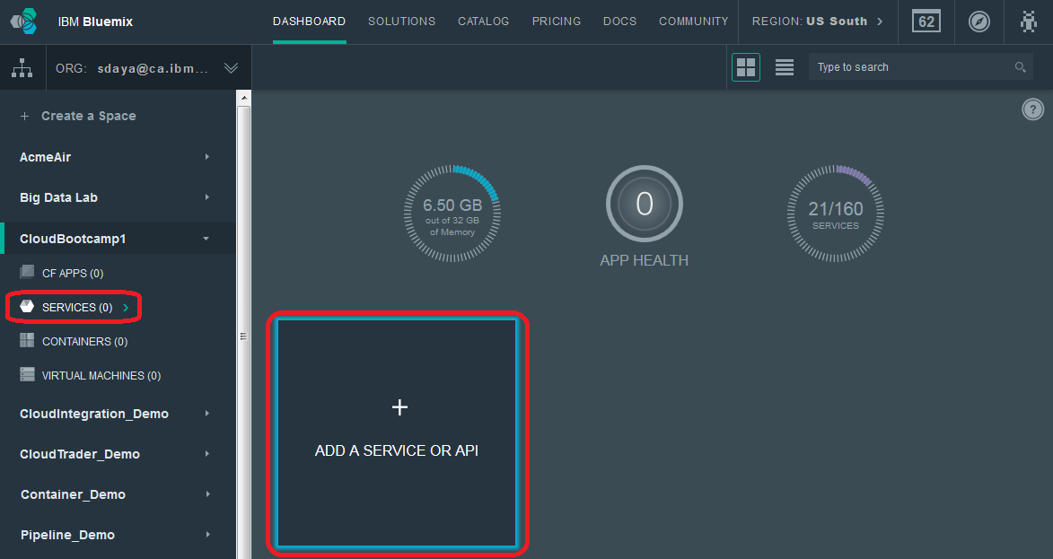
Look for a MongoDB service in the catalog.
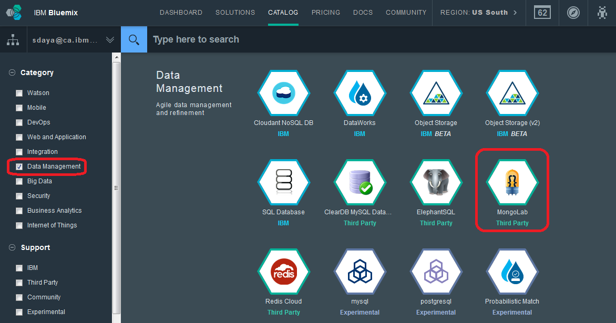
Click on the MongoLab service.
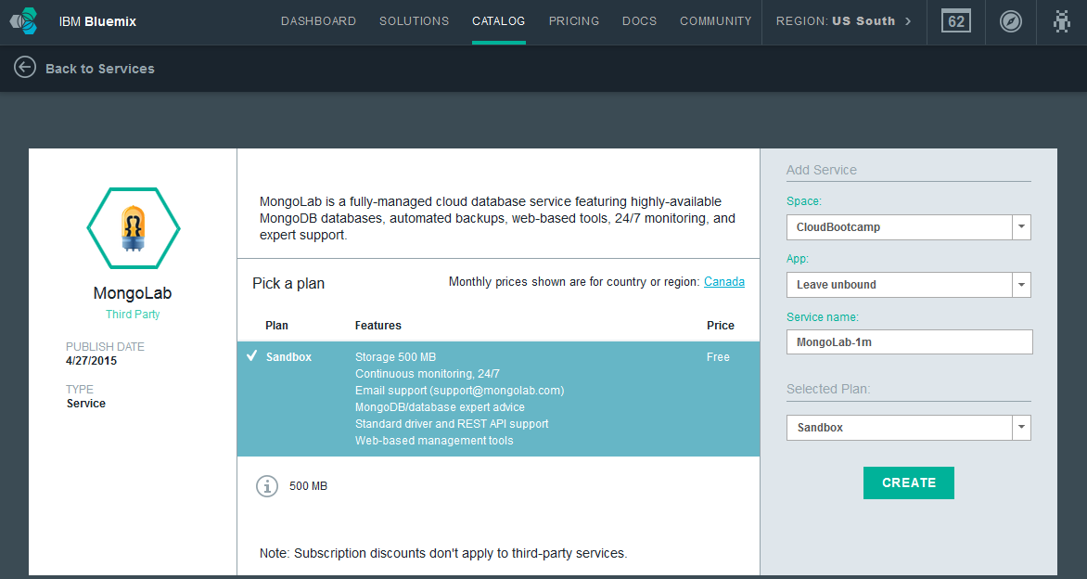
Click the CREATE button to create the service. You will see the following screen. Click on the Back to Dashboard link.
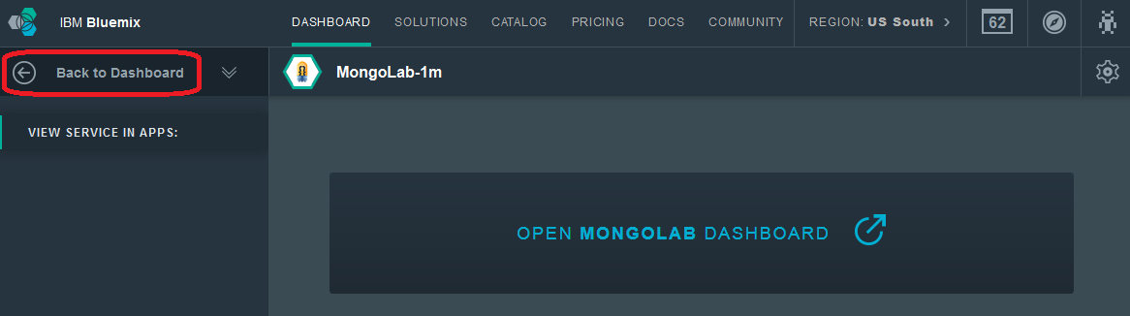
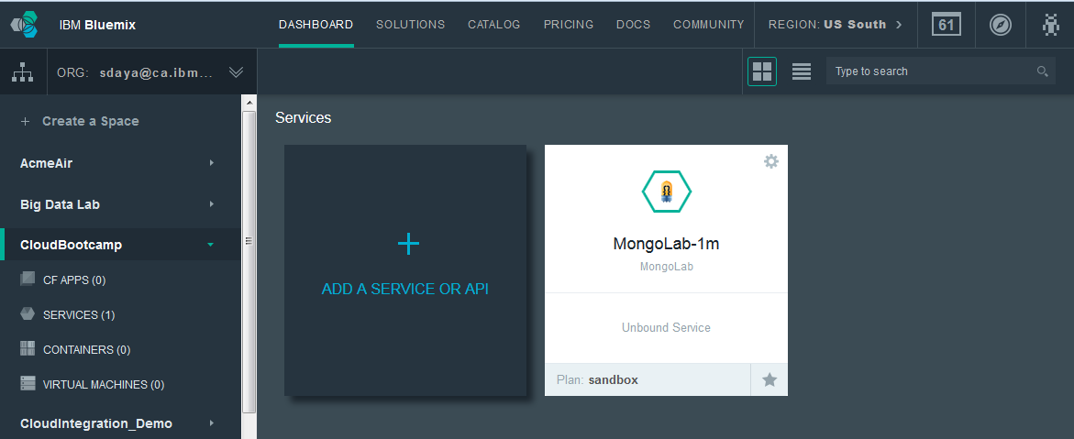
NOTE: There previously was a mongodb service provided by the community. This service may or may not be available via the Bluemix ACE UI. It is available using the cf command line interface. If instead of the MongoLab service described above, you would like to use the mongodb service, you can follow the following steps.
- To use the Cloud Foundry cf command line interface, we first need to install it first from https:/github.com/cloudfoundry/cli/releases.
- Login to Bluemix using the cf CLI.
usage: | $ cf login [-a API_URL] [-o ORG] [-s SPACE]
example: | $ cf login –a https://api.ng.bluemix.net
- List the available offerings in the marketplace to confirm that the mongodb service is available.
usage: | $ cf marketplace
The following is sample output:
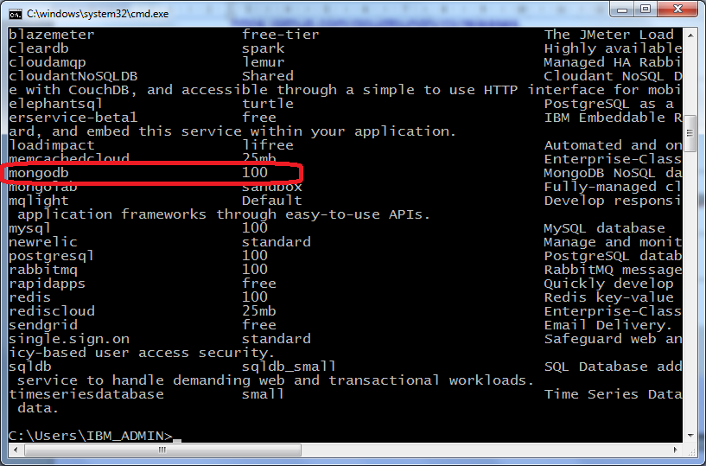
- Create an instance of the mongodb service, selecting a Service Plan level, and giving it a unique name in the last argument.
usage: | $ cf create-service SERVICE PLAN SERVICE_INSTANCE
example: | $ cf create-service mongodb 100 mymongodb-sd
You can now bind to the mymongodb-sd service when you push the application to Bluemix.

Create Bluemix Server in Eclipse
In this section you will create a Server using Eclipse. This exercise uses the Kepler Edition of Eclipse. It will also use the Eclipse Tools for Bluemix plug-in. If you do not have these installed, please look in the References section for a reference to the installation instructions.
- Open Eclipse and locate the Servers view
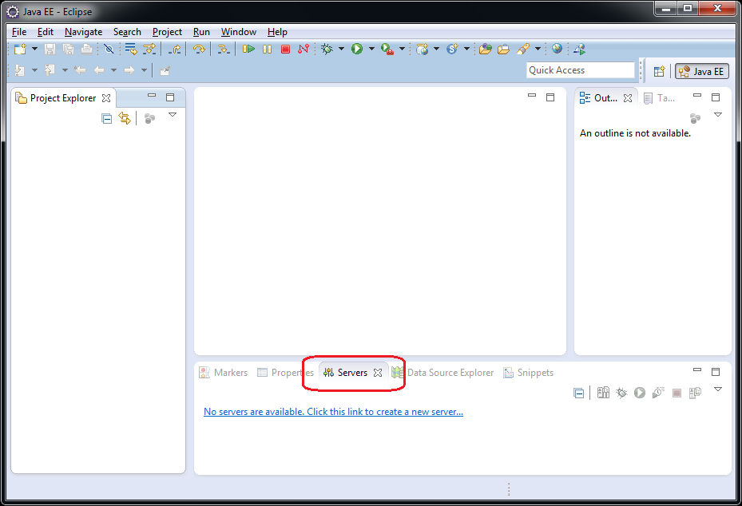
- Observe that you haven't defined any Servers so far. Click on the link to create a new server
  - Click No Servers are available. Click this link to create a new server…
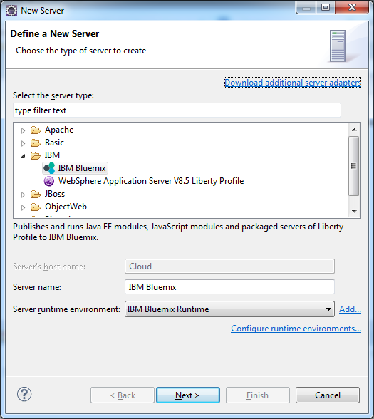
  - Choose IBM Bluemix under IBM and click Next >
  - In the New Server Window, enter your Bluemix account credentials (email and password)
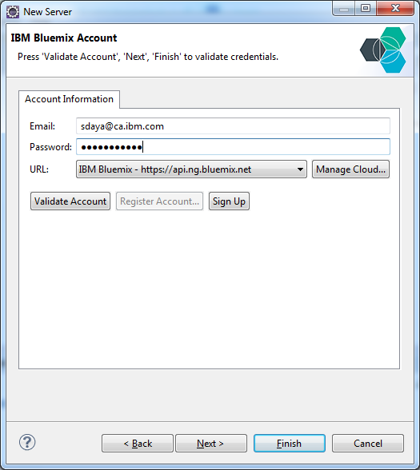
  - Click on Validate Account to validate the credentials before proceeding further.
  - Click Next. The list of organizations and spaces are displayed.
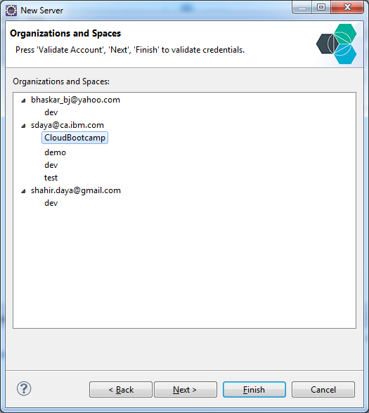
  - Choose the CloudBootcamp Space and click Finish.
  - The Bluemix Server is created and ready for your applications to be deployed from Eclipse.
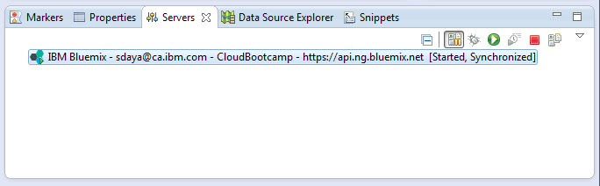

Create Dynamic Web Project using Eclipse
In this section you will create a Server using Eclipse. Again this exercise uses the Kepler Edition of Eclipse.
- Open Eclipse and work with a new workspace
- Create a Dynamic Web Project
- Click File → New → Dynamic Web Project
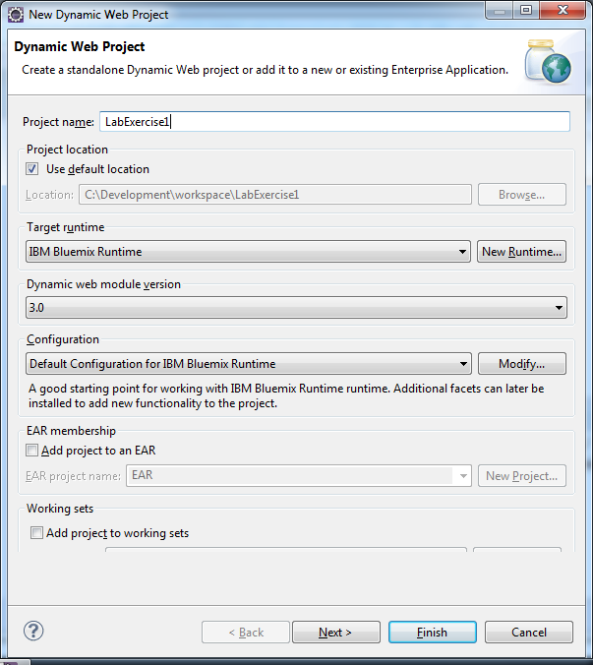
- Specify the application name as LabExercise1 and click Next.
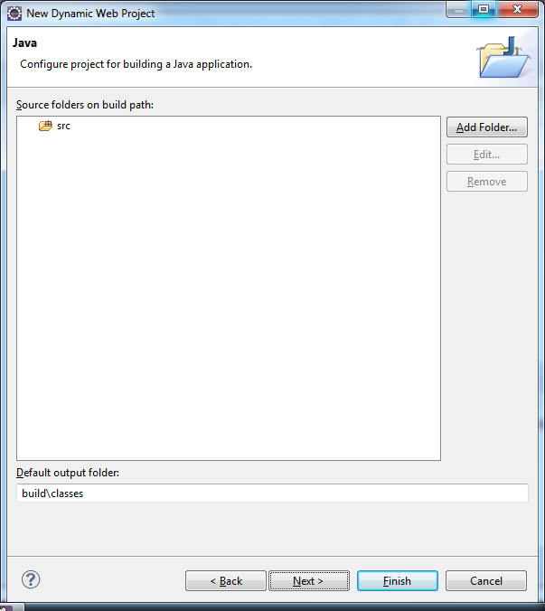
- Accept the default source and output folders. Click Next
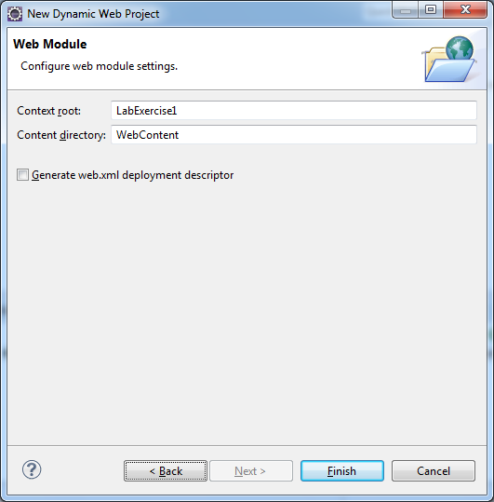
- Accept the default context root name and content directory. Check the generate web.xml and click Finish.
- Create a Servlet
- Expand the LabExercise1 Project and navigate to the source folder. Click New > Servlet to create a new Servlet.
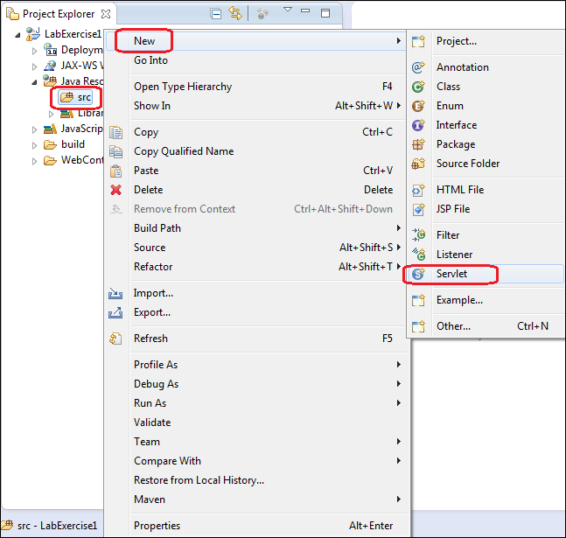

- Specify com.ibm.bluemix.demo.util as the package name. Enter BluemixDemoServlet as the class name. Click Finish to create the Servlet.
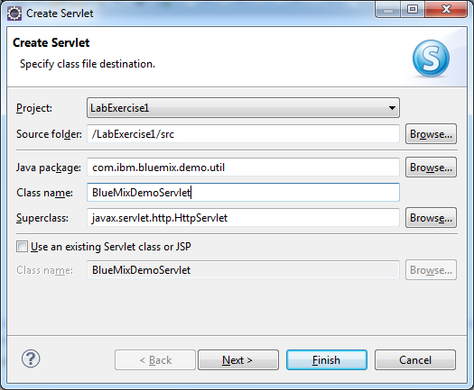
- The code for the web application is provided in a zip file embedded below. Unzip the file contents to a directory on your local machine.
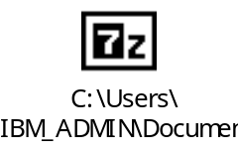
- Locate the BluemixDemoServlet.java file from the unzipped directory and copy the contents to the Servlet code in Eclipse.
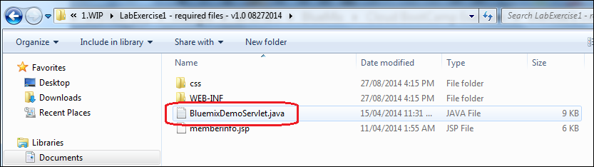
- Save the BluemixDemoServlet code in Eclipse and close.
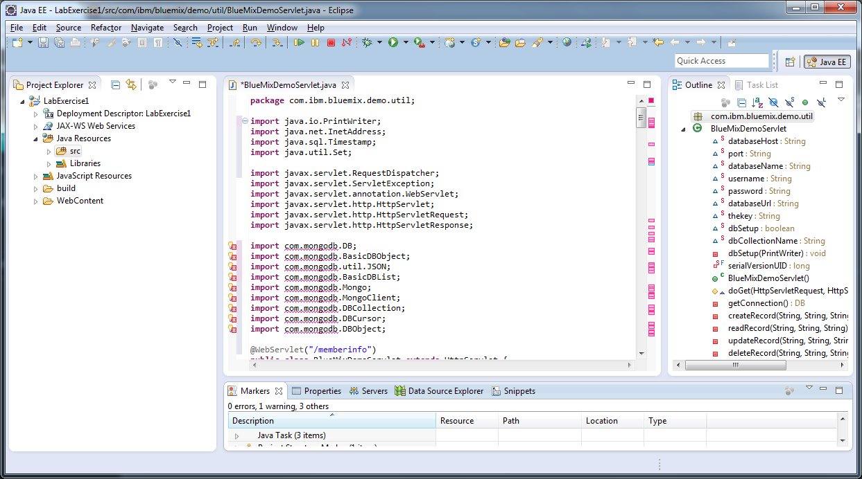
For now ignore the errors and warnings.
- Locate the web.xml under WEB-INF folder. If it exists, delete it. In the illustration below, it does not exist.
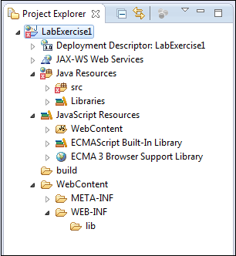
- Create a web.xml file in the WEB-INF folder
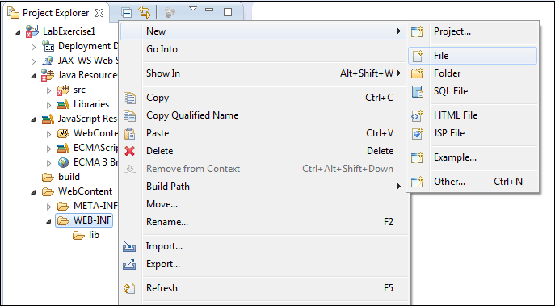
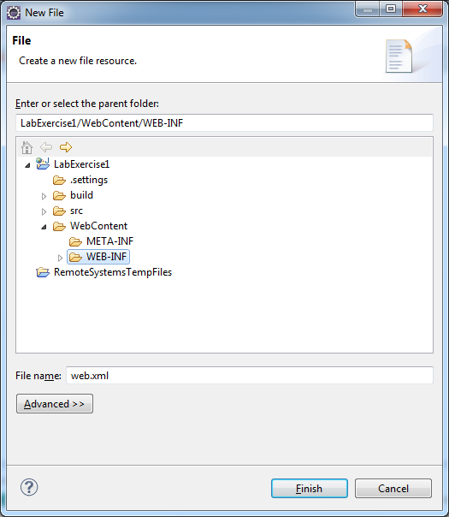
- Copy the content shown below to this file. Save and close web.xml.
<web-app xmlns:xsi="http://www.w3.org/2001/XMLSchema-instance" xmlns="http://java.sun.com/xml/ns/javaee" xmlns:web="http://java.sun.com/xml/ns/javaee/web-app_2_5.xsd" xsi:schemaLocation="http://java.sun.com/xml/ns/javaee http://java.sun.com/xml/ns/javaee/web-app_3_0.xsd" version="3.0">
<display-name>BlueMixDemo</display-name>
<welcome-file-list>
<welcome-file>memberinfo.jsp</welcome-file>
</welcome-file-list>
</web-app>
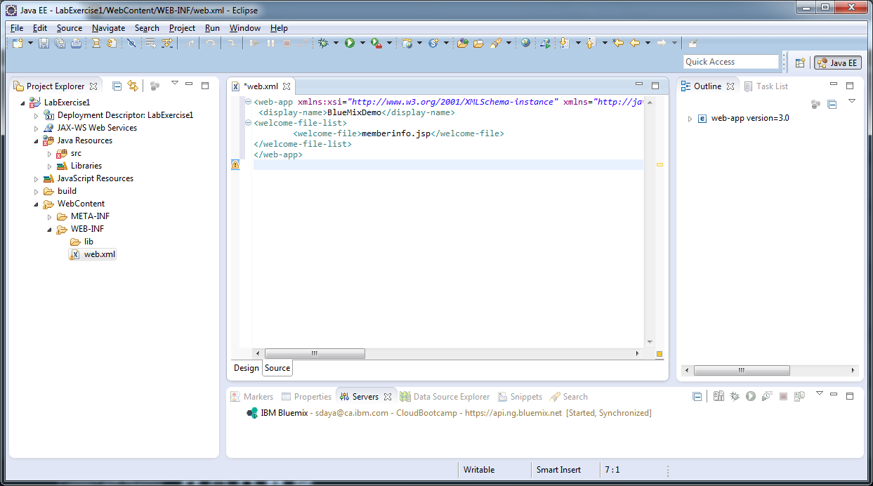
- The web.xml states that the welcome file for this application is memberinfo.jsp
- From the unzipped directory locate memberinfo.jsp and copy it under the webcontent directory. Also copy the css folder to the webcontent directory.
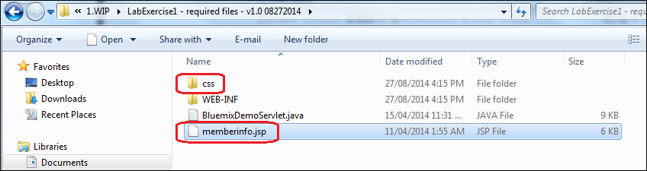
- The application uses Mongo DB. The Mongo DB Jar files needs to be in its class path during compilation and run time. Web Applications typically keep them under WEB-INF/lib. Copy the mongo-java-driver-2.11.3.jar from the unzipped folder (under WEB-INF/lib and copy it to WebContent/WEB-INF/lib folder.
- The Dynamic web project should look like the figure below.
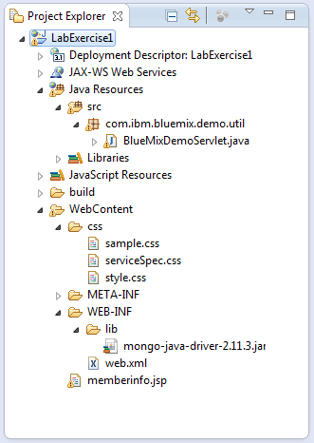
- The default configuration for Eclipse is to perform build automatically. Examine the problems view and ensure that there are zero errors. You might see a number of warnings but they can be safely ignored for this exercise. The problems view is typically in the bottom right (as shown below)
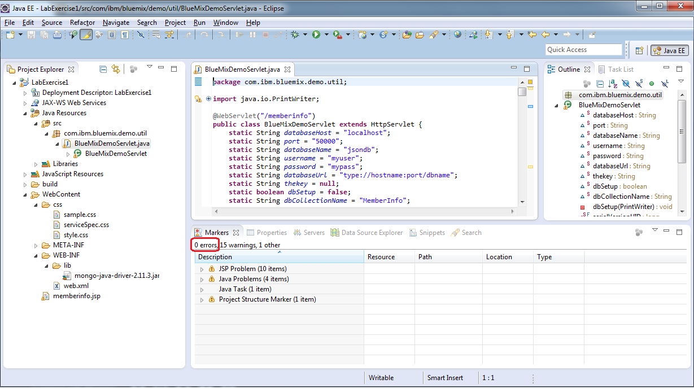
The web application is ready to be published to Bluemix.

Publish Web Application to Bluemix
- Switch to the Servers view and locate the Bluemix Server that you created earlier.
- From the context-menu for the Server, choose Add and Remove ...
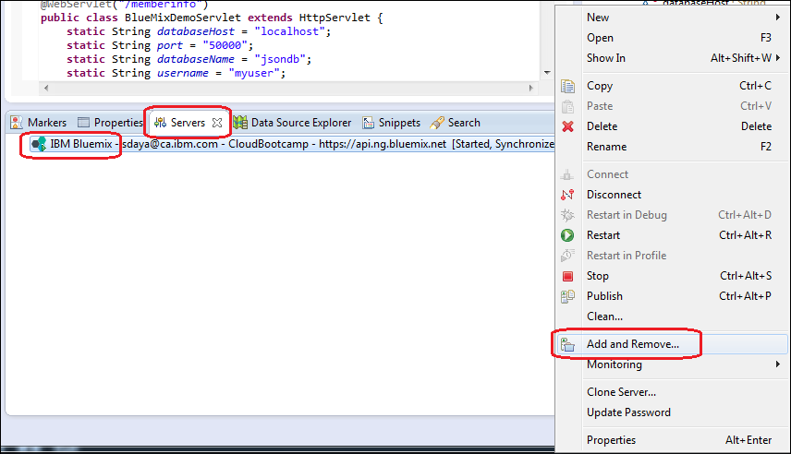
- Select LabExercise1 and Click on Add to publish the application
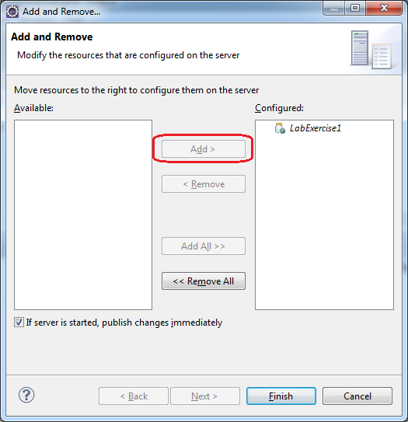
- Click Finish to add this project to the server.
- In the Application Details window, accept the defaults and click Next.
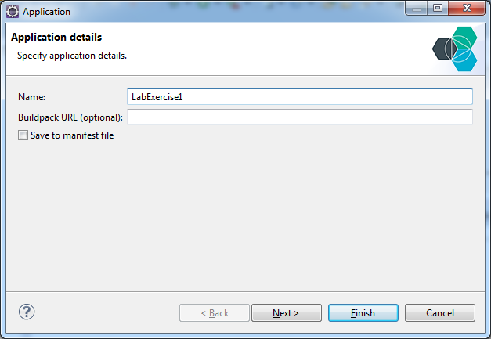
- Change the sub-domain name to ensure that it is unique. If it is not unique, then an error message will be displayed.
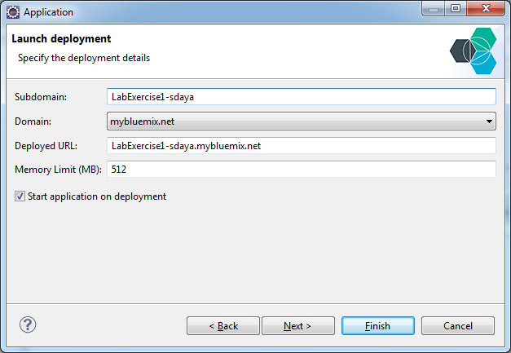
- The Deployed URL changes automatically. The Deployed URL is the URL that you and other users would use to access this application. Click Next.

- In the Services selection window, choose the mongodb service. This is the service that you created in the "CloudBootcamp" Space earlier using the Bluemix Dashboard.
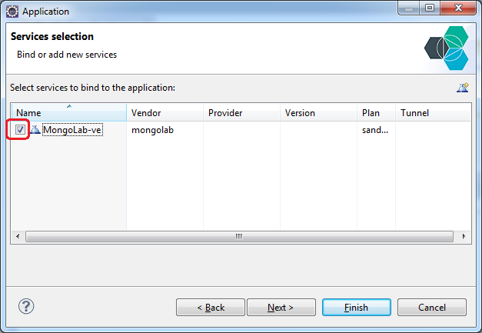
- The application does not use any custom variables. You can click Finish in the Environment variables page.
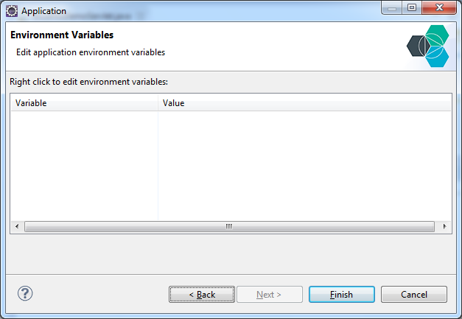
- Switch to the console view to see the progress of your application deployment.
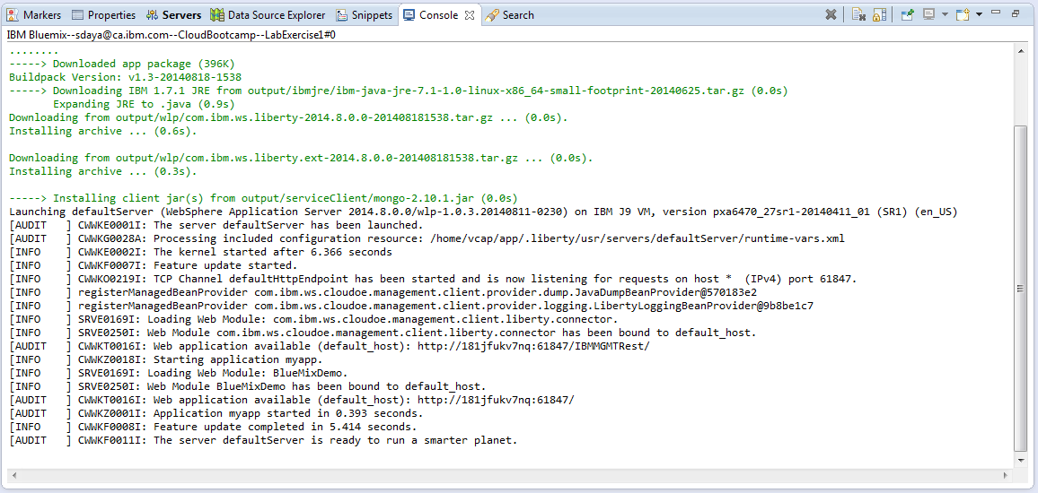
- The phrase - "ready to run a smarter planet" indicates that the application has been successfully deployed.
Now you can access the application via its deployed URL. You can also see your application in the Bluemix ACE UI.
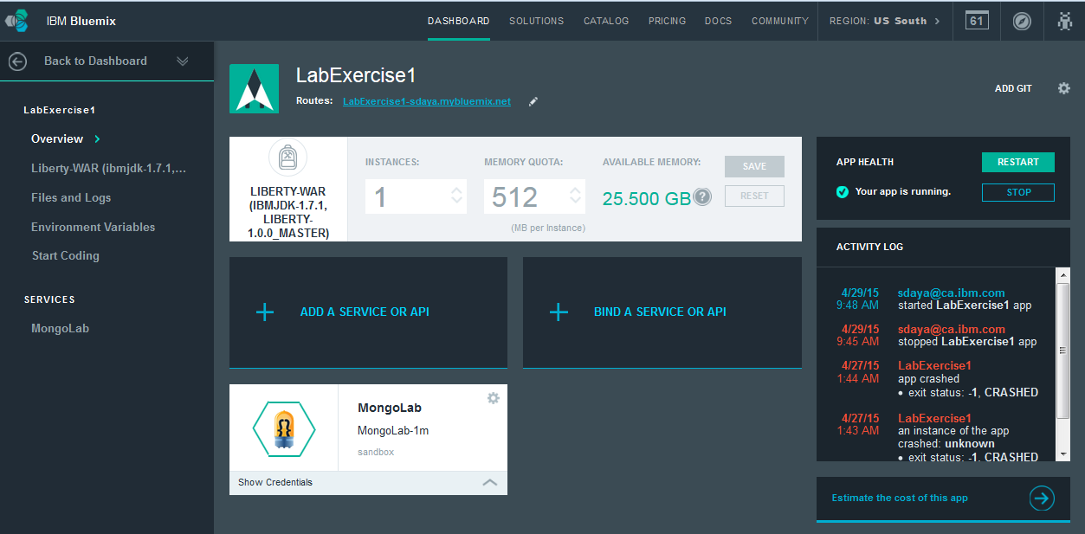

Test Web Application
In this section you will create test the web application.
- Open up a Web Browser and navigate to the Deployed URL of the application.
- The contents of the welcome file (memberinfo.jsp) should be displayed in the browser.
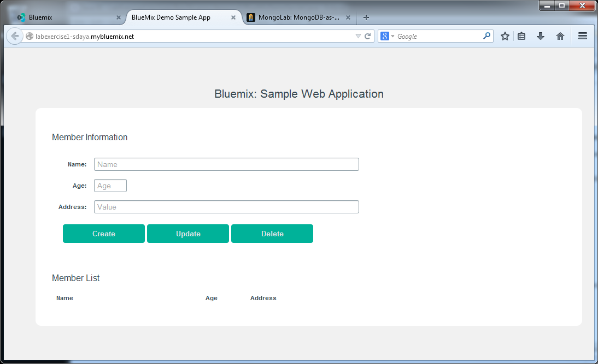
- Enter values in the form fields and click on Create.
- The values should be stored in the Mongo DB Database and should appear in the Member List section.
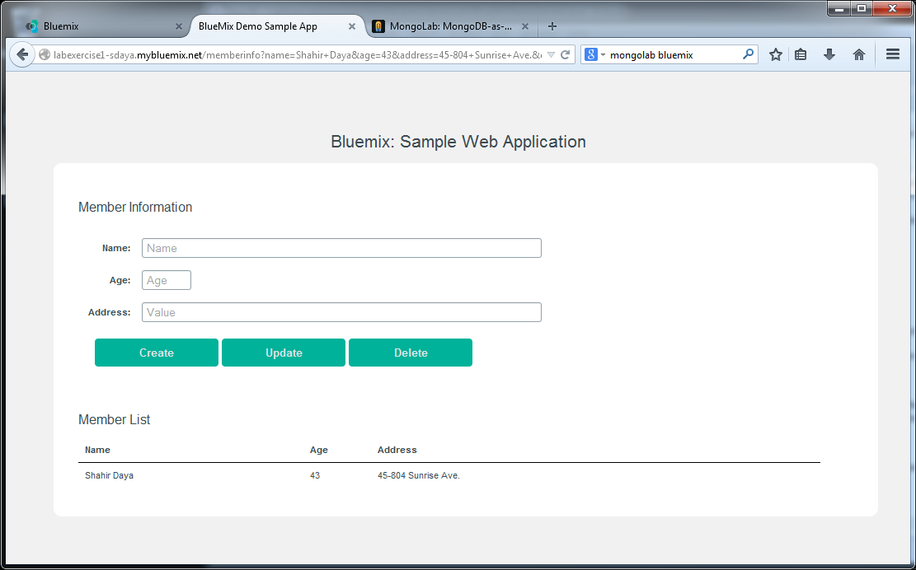
- Play with the application and try creating a few more records.
- Switch to Eclipse and look at the console view and observe the contents.
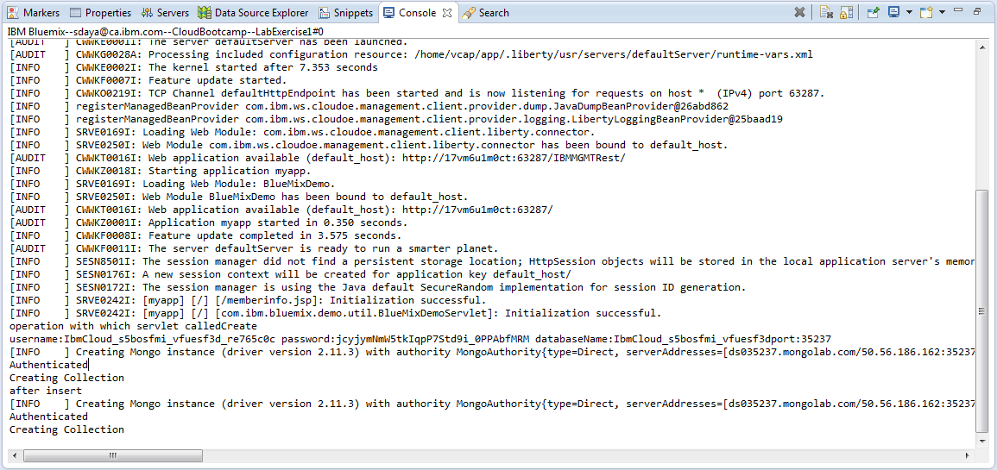
- The Console shows the SystemOut and SystemErr of the server instance hosting your application.
In this exercise, you created a web application using Eclipse. The Web application is bound to a Mongo DB service to write information to a Mongo DB database. The application was published to Bluemix using the Eclipse Tools for Bluemix plug-in.

References
https://www.ng.bluemix.net/docs/starters/deploy_eclipsetools.html

END OF DOCUMENT

